**The scenario**

In an effort to enhance its efficiency and provide exceptional healthcare, the clinic adopted an integrated management system to ensure the highest levels of organization and accuracy.

1. Appointment Scheduling:  
Patients can now easily book their appointments through the online booking portal. Upon accessing the system, a list of available time slots is displayed according to the clinic’s schedule. After selecting a suitable time, the patient confirms the booking, and the appointment is directly added to the clinic’s schedule. This method streamlines the booking process and reduces pressure on the staff.

2. Patient Records Management:  
Upon the patient’s arrival, the dentist can instantly access their medical record through the system. The record includes details of previous treatments, allergies, and current medications, helping the dentist make accurate treatment decisions based on reliable data.

3. Appointment Reminders:  
To reduce the likelihood of no-shows, the system automatically sends reminders via SMS or email before the scheduled appointment. This feature helps improve appointment management and ensures better patient compliance.

4. Treatment Cost Estimation:  
Before beginning any treatment, the dentist inputs the treatment plan into the system, which then calculates an estimated cost based on the required procedures. This estimated cost is displayed to the patient, helping them make an informed decision about the treatment based on their financial considerations.

5. Treatment Documentation:  
During the patient’s visit, the dentist documents the treatment details in real-time using the system. The system supports both manual data entry and voice-to-text functionality, making documentation easier and ensuring accurate information is recorded.

6. Patient Portal:  
After treatment, the patient can log into a secure online portal to view their medical records. The portal provides access to details of past treatments, upcoming appointments, and any related reports, allowing the patient to continuously monitor their health.

7. Reporting and Analytics:  
The clinic manager uses the system’s reporting and analytics tools to generate comprehensive reports on the clinic's performance. The system creates weekly or monthly reports containing appointment statistics, types of treatments provided, and revenue data, helping in making strategic decisions to improve clinic operations.

* **The user story**

|  |  |  |
| --- | --- | --- |
| **User Story** | **Functionality** | **Internal System** |
| **As a dentist, I want to access patient records quickly to make accurate treatment decisions** | **Retrieve and display patient medical history, including previous treatments, allergies, and medications** | **Patient Records Management System** |
| **As a patient, I want to book appointments online at my convenience** | **Online appointment booking with integration into the clinic's schedule** | **Appointment Scheduling System** |
| **As a Secretary, I want reminders sent to patients before their appointments to reduce no-shows** | **Automated notification system for sending reminders via SMS or email** | **Notification and Reminder System** |
| **As a patient, I want to receive a detailed cost estimate before starting any treatment** | **Generate and display cost estimates based on the treatment plan.** | **Billing and Treatment Estimation System** |
| **As a dentist, I want to document treatment details efficiently during patient visits** | **Real-time data entry for procedures performed, with voice-to-text options** | **Treatment Documentation System** |
| **As a clinic manager, I want to generate reports on clinic performance and patient flow** | **Analyze data to produce monthly or weekly reports on appointments, treatments, and revenues.** | **Reporting and Analytics System.** |
| **As a patient, I want access to my dental records through a secure online portal** | **Patient portal with secure login for viewing records, upcoming appointments, and past treatments.** | **Patient Portal System.** |

**Use case**

**1. Online Appointment Booking**

**Actor:** Patient  
**System:** Appointment Scheduling System

|  |  |  |  |  |  |
| --- | --- | --- | --- | --- | --- |
| |  | | --- | | **Actor Actions** | | 1. Patient accesses the online booking portal  3. Patient chooses a suitable appointment  5. Patient confirms the appointment  7. Patient receives confirmation notification | | |  | | --- | | **System Actions** | | 2. System verifies the patient’s identity  4. System displays available slots  6. System saves the appointment to the clinic’s schedule  8. System sends an appointment confirmation via email/SMS | |

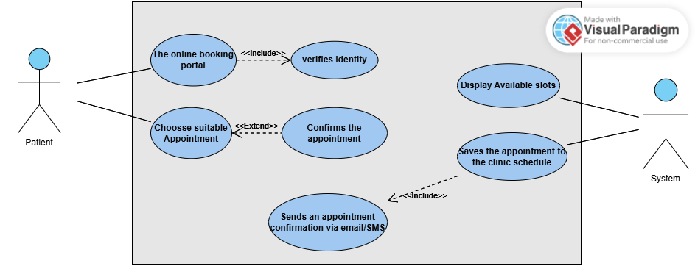

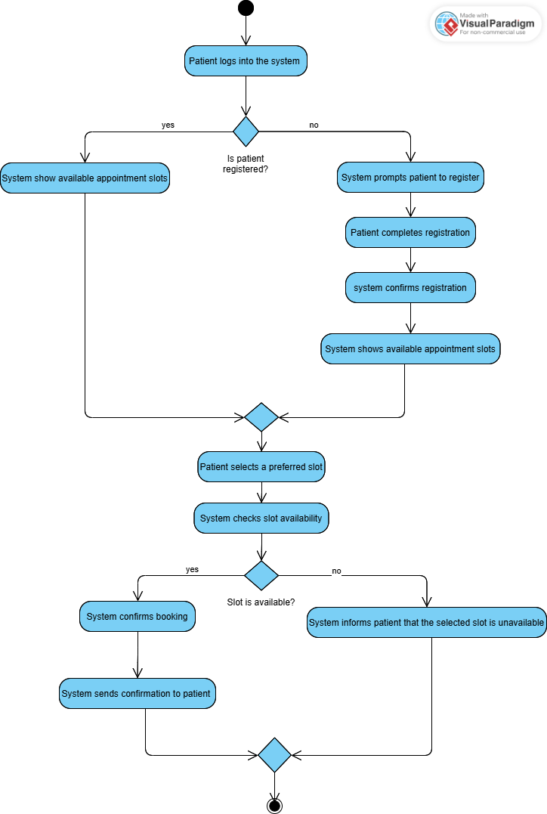

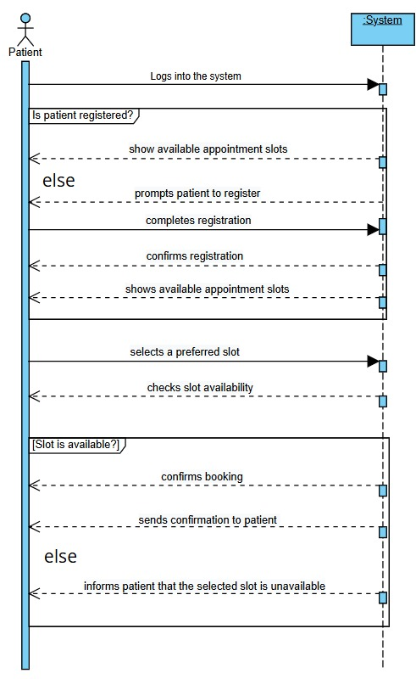

**2. Patient Records Access for Dentist**

**Actor:** Dentist  
**System:** Patient Records Management System

|  |  |
| --- | --- |
| **Actor Actions** | **System Actions** |
| |  |  | | --- | --- | | 1. Dentist logs into the system |  | | |  |  |  |  | | --- | --- | --- | --- | | 3. Dentist searches for a specific patient record | |  |  | |  | 5. Dentist reviews medical history and allergies | |  |  |  | | --- | |  | | 2. System verifies dentist credentials  4. System retrieves and displays the patient record  6. System ensures data integrity and updates access logs |

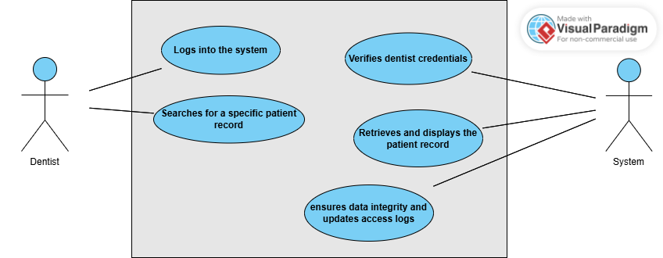

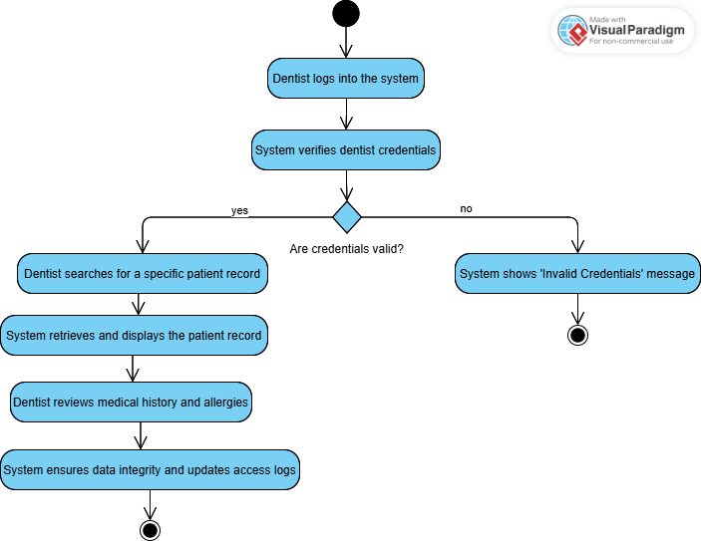

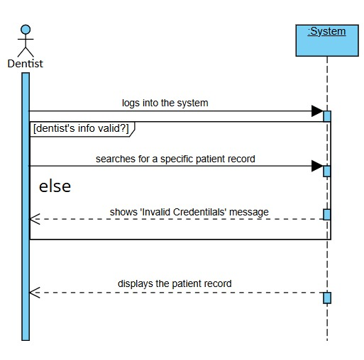

**3. Treatment Cost Estimation**

**Actor:** Dentist, Patient  
**System:** Billing and Treatment Estimation System

|  |  |  |  |
| --- | --- | --- | --- |
| |  | | --- | | **Actor Actions** | | |  | | --- | | **System Actions** | |
| 1. Dentist inputs the treatment plan details   3.System displays the estimated cost to patient  5. Dentist confirms the treatment plan | |  | | --- | |  |  1. System calculates the estimated cost   4.Patient reviews and approves the treatment plan  6. System saves the approved plan and cost estimate |

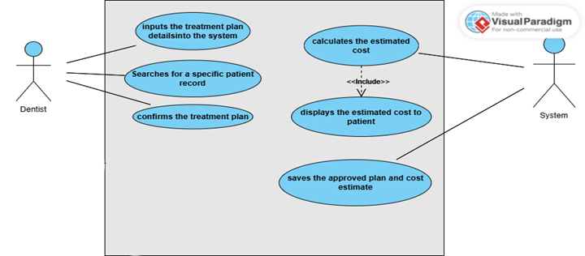

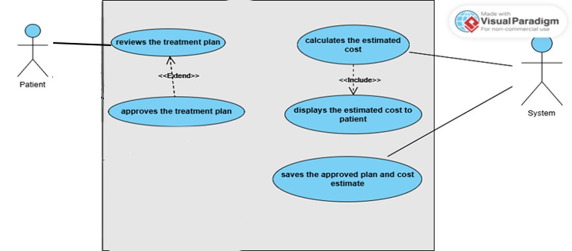

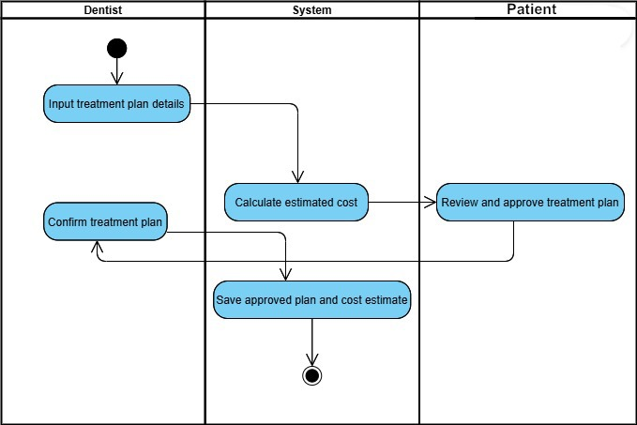

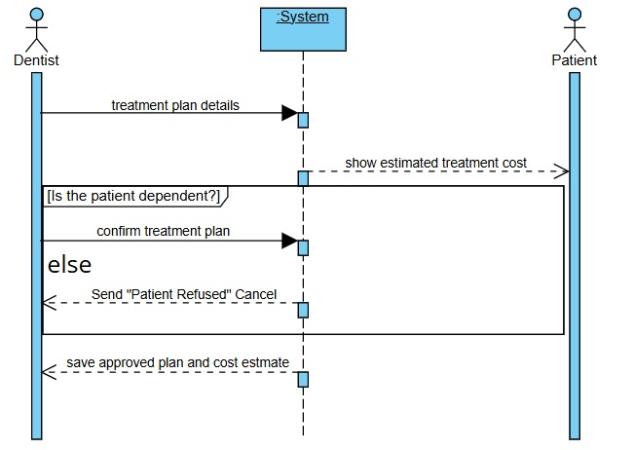

**4. Treatment Documentation**

**Actor:** Dentist  
**System:** Treatment Documentation System

|  |  |
| --- | --- |
| **Actor Actions** | **System Actions** |
| 1. Dentist opens patient’s active record   3.Dentist documents the treatment details   |  | | --- | | 5. Dentist saves the documentation | | 2. System displays the treatment entry interface  4. System supports manual or voice-to-text entry  6. System updates and saves treatment records |

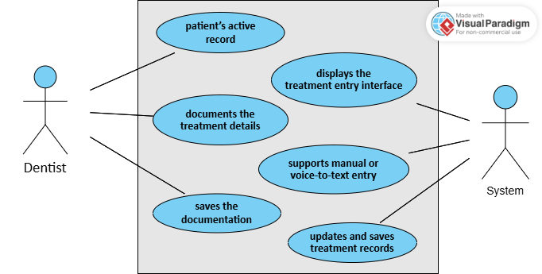

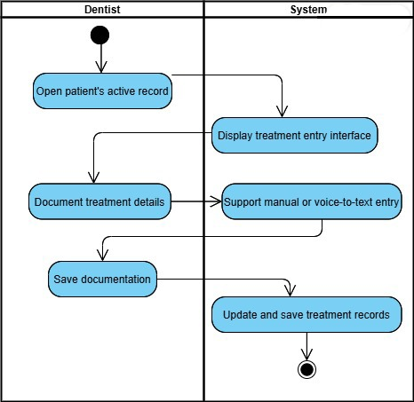

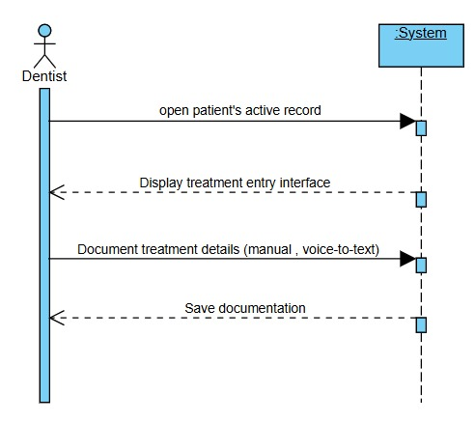

**5. Access Patient Portal**

**Actor:** Patient  
**System:** Patient Portal System

|  |
| --- |
|  |
| **Actor Actions** | **System Actions** |
| 1. Patient logs into the online portal  3. Patient navigates to “My Records” section  5. Patient views past treatments and appointments | 2. System verifies patient credentials  4. System retrieves and displays medical records  6. System ensures secure and encrypted access |

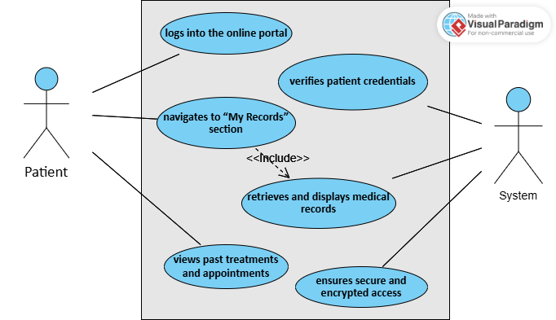

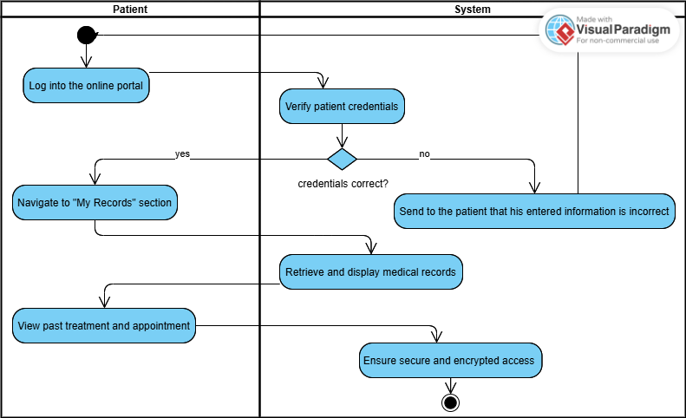

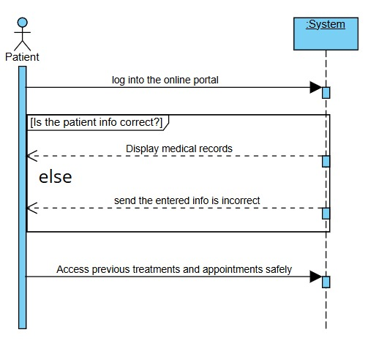

**6. Generate Reports on Clinic Performance**

**Actor:** Clinic Manager  
**System:** Reporting and Analytics System

|  |  |
| --- | --- |
| **Actor Actions** | **System Actions** |
| 1. Clinic manager logs into the system   |  | | --- | | 3. Manager selects the desired report type | |  |   5. Manager generates the report | |  | | --- | | 2. System verifies manager credentials  4. System retrieves data from appointments, revenues, etc.  6. System displays the report in visual/printable format |  |  | | --- | |  | |

